PROPOSED CONDITIONS ATTACHED TO DEVELOPMENT CONSENT NO. DA-112-2019
Please read all conditions carefully. The applicant/developer may arrange to meet with Council to review and clarify, if necessary, the precise requirements of the conditions of this consent.
Note: A copy of all conditions contained in this consent are to be provided to contractors and subcontractors working on the site, to ensure all work is carried out in accordance with this consent.
PRESCRIBED CONDITIONS
For the purposes of section 80A (11) of the Act, the following conditions are prescribed conditions of development consent:

136A EP&A Regs 2000: Compliance with Building Code of Australia
(1) For the purposes of section 80A (11) of the Act, the following conditions are prescribed in relation to a development consent for development that involves any building work:
(a) that the work must be carried out in accordance with the requirements of the Building Code of Australia.

GENERAL CONDITIONS
1. | To ensure this development is consistent with Council’s consent, the development must take place in accordance with the submitted and approved Statement of Environmental Effects and appendices prepared by Eco Logical Australia and their consultants and dated August 2019 (bearing the Armidale Regional Council approval stamp); and all other documents submitted with the application, and subject to the consent conditions in this notice. In the event of any inconsistency between the approved plans and the conditions of this consent, the conditions shall prevail.  ADVISING: Further consent may be required for any change, enlargement or intensification of the premises or land use, including the display / erection of any new structure (unless the proposed work is exempt from the need for consent). Please check with Council before commencement.
2. | All Engineering works to be designed by a competent person and carried out in accordance with Council’s Engineering Code, unless otherwise indicated in this consent, to ensure that these works are of a sustainable and safe standard.
3. | All existing trees on the site/s are to be retained and protected from damage during work on the site, (with the exception of those identified within the Development Site itself), to maintain the visual amenity of the locality and no buildings are to be constructed or utility service mains installed within 3 metres of the trunks of these trees, so as not to prejudice their future retention.
4. | Prior to the commencement of construction, the decommissioning of the development or the cessation of operations, the applicant/land owner must notify Armidale Regional Council in writing of the date of commencement, decommissioning or cessation (whichever is relevant).
5. | Materials and their finishes/colours of any proposed site building/ panels and arrays/ infrastructure related to the development is to be selected to blend with the surrounding landscape and are not to be reflective in nature, to ensure that they visually integrated with the surrounding environment.

BEFORE RELEASE OF s138 APPROVAL
6. | The high risk rated CARs identified in the Road Safety Audit (Stage 5 – Road Safety Audit: Stringy Bark Solar Farm Transportation Route Revision 2, Constructive Solutions Pty Ltd, 24/07/2019) are to be actioned and made good to improve driver safety along Gara Road.  Additional improvement measures required as part of the Gara Road safety improvements include:  - A ‘crest ahead’ sign and ‘hidden driveway’ sign to be erected at the approach to 300 Gara Road for western bound traffic; and  - The reduction in batter grades at both approaches to the Burying Ground Creek Causeway to improve driver visibility.  Plans demonstrating compliance with the above matters to be provided to Council with a s138 Application.  The s138 Application must be approved before the issue of a Construction Certificate for the development.  Approved works to be completed in accordance with the approval prior to the solar farm construction phase commencing.
7. | Engineering designs are to be submitted detailing the following works required for the development:  - The intersection with Grafton Road and Gara Road is to be upgraded to include both a rural style BAL and BAR turning treatments. Treatments are to be designed in accordance with Austroads standards  - The Grafton Road access to the sub-station is to be upgraded to a Rural Residential Access Standard and an Austroads BAR right-turn treatment to mitigate the reduced sight distance for approaching eastbound traffic. The access should be sealed for 30m to reduce tracking of material onto the Waterfall Way.  - These proposed roadworks on the Grafton Road Way will require a Works Authorisation Deed (WAD) to be executed with Roads and Maritime Services. Roads and Maritime encourages applicant to commence this process early to avoid any delays.  The detailed design, which is to be submitted to the satisfaction of Council via a s138 Roads Act Application, is to ensure that works at the Grafton/Gara Road intersection have taken into consideration the location of the heritage culvert (I222) in the locality and that such works do not impact on this Item.  In the event that any works are within the vicinity of this site that may impact on the Item, a Heritage Assessment and Heritage Impact Statement must be prepared and submitted with Engineering designs for Council’s consideration.  The s138 Application must be approved before the issue of a Construction Certificate for the development.  Approved works to be completed in accordance with the approval prior to the solar farm construction phase commencing.

8. | A Dilapidation Report for Gara Road, pre and post construction, is to be prepared and submitted to the satisfaction of Council prior to any road works being undertaken.  Such report is to be undertaken in conjunction with Council’s Roads Manager or nominee, to identify the condition of the roadway prior to works commencing so that any damage to the road during construction works can be rectified on completion of these works and prior to the operational phase of the development commencing.  Such Report should also include provisions for any upgrading/rectification works required to be undertaken by the developer both during and post construction works, in the event that the road surface becomes damaged during works as a result of any development related vehicles and is required to be rectified.
BEFORE RELEASE OF CONSTRUCTION CERTIFICATE

9. | In accordance with the SEE, the Applicant is to prepare the following Plans for the development:  - Emergency Response Plan (ERP);  - Construction Environmental Management Plan (CEMP), which is to include but not limited to:  - Environmental measures to be implemented for any hazardous materials stored on site and prevent their offsite migration;  - Details for the storage of any hazardous materials on site;  - A Spill Response Plan (SRP)  - ESCP;  - Details and protocols for any on-site refuelling and details of the disposal of these materials;  - Details during the construction phase to ensure that there is a qualified ecologist present on site to supervise any clearing works and identify fauna roosting or nesting habitat in accordance with best practice methods to relocate fauna in a sensitive manner. Furthermore, the Plan is to incorporate all mitigation measures during clearing as proposed in the SEE.  - Operational Environmental Management Plan (OEMP), which is to include but not limited to:  - Inspection program following significant storm events, identifying rectification works required to stabilise the site, access roads and all site infrastructure;  - Inspection program to repair/replace faulty panels before they may become hazardous to the environment by way of deterioration/damage to prevent any contamination from occurring either on or off site.  - Construction Noise and Vibration Management Plan;  - Biodiversity Management Plan (BMP);  - Bushfire Management Plan (BMP);  - Community Consultation Plan (CCP);  Such Plans are to be submitted to and approved by the relevant certifying authority before the issue of a Construction Certificate and implemented/adopted for the life of the development.

10. | The plans accompanying the Construction Certificate for any building related works are to demonstrate compliance with the Building Code of Australia (BCA). Plans are to be submitted to the Principal Certifying Authority for the authentication of BCA compliance and issue of a Construction Certificate.
11. | The preparation of a detailed Stormwater, and Erosion and Sediment Control Plan (ESCP) and accompanying specifications for both the construction phase of the works and also the operation and decommissioning phases, shall be submitted to and approved by the relevant certifying authority before the issue of a Construction Certificate for the development.  The approved ESCP controls shall be implemented, inspected and approved by the Certifier prior to the commencement of any site works and maintained for the life of the construction/operation phase and until revegetation measures have taken hold. The ESCP shall include, but not be limited to:  - Inclusion of the recommendations of the Agronomy Report (Agronomy Report – “Sharraloy”, GrazAg, October 2019);  - Inclusion of the recommendations of the Hydrology Report (Stringybark Solar Farm Hydrology Assessment, Eco Logical Australia, October 2019);  - Provision for the diversion of runoff around disturbed areas;  - Location and type of proposed erosion and sediment control measures;  - Location of and proposed means of stabilisation of site access;  - Approximate location of site sheds and stockpiles;  - Proposed staging of construction and ESCP measures;  - Clearance of sediment traps on a regular basis and after major storms;  - Details to be implemented to prevent increased runoff and/or sedimentation impacting on any adjoining properties, gullies and drainage lines;  - Details of routine erosion monitoring for the life of the development, including but not limited to the monitoring of any scarring beneath the panel arrays and along access tracks and waterways;  - Regular inspection program;  - Details of measures during decommissioning of the site;  - Proposed site rehabilitation measures, including seeding of all bare un-grassed areas and turfing where erosion or scouring is likely to occur;  - Standard construction drawings for proposed erosion and sediment control measures.  ADVISING: Failure to take effective action may render the developer liable to prosecution under the NSW Protection of the Environment Operations Act.

 | 12. | The Applicant is to prepare and submit a detailed Waste Management Plan (WMP) outlining all waste management principles and practices relevant to the proposed development and to meet the objectives as set out in the SEE, to reduce waste and recover resources.  The Plan must implement best practice measures during all activity on site for the life of the development, to ensure that all waste products such as but not limited to, cardboard, packaging/wrapping, plastics, panels and/or any other infrastructure related to the development is sorted and recycled to minimise recycled materials from being disposed with other bulk waste to landfill and identify opportunities to maximise reuse.  In this regard, the Plan must demonstrate procedures to be implemented to ensure that waste products are separated and recycled at the appropriate facilities.  Full details are to be provided to the satisfaction of the relevant Certifying Authority prior to the release of a Construction Certificate for the development.
13. |  | Submission of a detailed Construction Management Plan, shall be submitted to and approved by the relevant certifying authority before the issue of a Construction Certificate for the development, to ensure that work is undertaken safely and to minimise nuisance to the surrounding area during all construction/work on site. This Plan shall include, as a minimum:  - Off-street parking for employees, contractors, sub-contractors and visitors to the site.  - Public parking during construction;  - Mini bus collection site and off-site parking arrangements for contractors/construction workers;  - Site access for construction vehicles and equipment;  - Storage and removal strategies for construction wastes;  - Construction Traffic Management Plan;  - Provision of sanitary amenities and ablution facilities for employees;  - Fire precautions during construction;  - Dust suppression management measures;  - Control of noise arising from the works in accordance with the requirements of the Protection of the Environment Operations Act 1997 and guidelines contained in the New South Wales Environment Protection Authority Environmental Noise Control Manual;  - Fencing and security details, including site hoardings to be provided, safeguarding both contractors and the public while works are being carried out on any public footpath areas;  - Details of all construction-related signs;  - Careful management of construction activities to prevent any contaminant discharge from the site (including oils, fuels, paints or chemicals), particularly with respect to excess concrete or concrete truck washings;  - Location of all public utility facilities and methods of protecting them; and  - Method of support to any excavation adjacent to adjoining properties, or the road reserve.

14. |  | The site must be decommissioned and restored to its original agriculture use/state on decommissioning/end of the lease/life of the development.  In this regard, the Applicant is to submit a detailed Decommissioning Management Plan (DMP) outlining all procedures and activities to be implemented for the decommissioning of the site. The plan is to include details of, but not limited to:  - Disconnection from the 66 kV offsite Substation;  - Dismantling and removal of the Substation and support buildings;  - Removal of the solar panels, tracking systems, inverters and cables;  - Removal of onsite tracks and fences unless agreed otherwise with the landowner; and  - Reinstatement of all disturbed ground.  Where possible and in accordance with the SEE, such plan must also include measures and opportunities to maximise the recycling of all products/materials at the end of their life, to ensure that they are appropriately disposed of responsibly and reuse is maximised while waste is minimised.  Full details are to be provided to the satisfaction of the relevant Certifying Authority prior to the release of a Construction Certificate for the development.
 | 15. | A Landscape Management Plan must be prepared for the development incorporating all recommendations within the SEE.  Additionally, the landscape plan must detail:  - Name and number of species (with preference on the use of native varieties);  - Height of species at planting;  - Height and spread of species at maturity;  - Method of site preparation and maintenance, to ensure likely survival of plant stock;  - Monitoring program to detect and replace dead or unhealthy plant stock;  - Weed management;  - Proposal for landscaping/screening of the site in the event of drought conditions prevailing, which may inhibit the landscaping planting being undertaken from the outset;  - Proposal for ongoing maintenance/watering of plantings to ensure their survival during drought conditions.  Such plan is to be provided to the satisfaction of the relevant Certifying Authority prior to the release of a Construction Certificate for the development.  Landscaping/screening required under this consent, is to be undertaken in accordance with the approved plan prior to the operational phase of the development commencing.
 | 16. | The discharge of stormwater is to be controlled to ensure that post-development follows do not exceed pre-development flows. The stormwater solution is to be designed by a suitably qualified engineer to prevent nuisance to adjoining land.  ADVISING: Approval from the Department of Primary Industries – Water may be required if it is proposed to discharge stormwater directly into an existing waterway.

17. | Given that the subject site may contain items of potential Aboriginal Heritage significance and that an Aboriginal site has ben recorded in or near the location of the land on which the development is proposed on the Aboriginal Heritage Information Management System (AHIMS), consultation is to be undertaken with the relevant Aboriginal stakeholders and OEH.  Evidence of such consultation being undertaken advising that the Aboriginal Community and OEH are satisfied that the proposed development would be unlikely to impact on any known sites/places, is to be provided to the satisfaction of the relevant Certifying Authority prior to the issue of a Construction Certificate.
18. | Approval is required from Council for the following activities pursuant to Chapter 7, Section 68 of the Local Government Act 1993:  - Installation, alteration, or operation of an on-site waste water management system,  - Installation of a moveable building,  Approval must be obtained prior to the issue of a Construction Certificate for the development.
19. | Prior to the issue of a Construction Certificate for the development, the Applicant is to submit a detailed excavation/earthworks plan for the proposed development, including but not limited to the panel array area and all ancillary works and include details and location of all stock piles on-site and proposed erosion and sediment controls to be installed to prevent runoff.
20. | In accordance with the Biodiversity Development Assessment Report and Addendums prepared by Eco Logical Australia for the development, the class and number of Ecosystem credits as detailed in the tables below, must be retired to offset the residual biodiversity impacts of the development.  The requirement to retire credits may be satisfied by payment to the Biodiversity Conservation Fund of an amount equivalent to the class and number of Ecosystem credits, as calculated by the BAM Credit Calculator (BAM-C).  Evidence of the retirement of credits or payment to the Biodiversity Conservation Fund in satisfaction of this condition, must be provided to the consent authority prior to the release of the Construction Certificate.

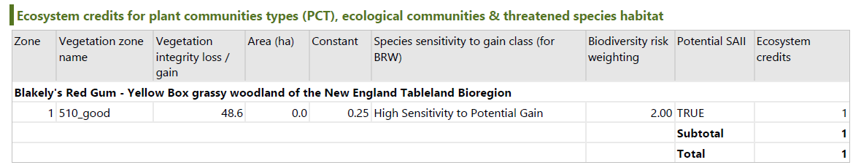

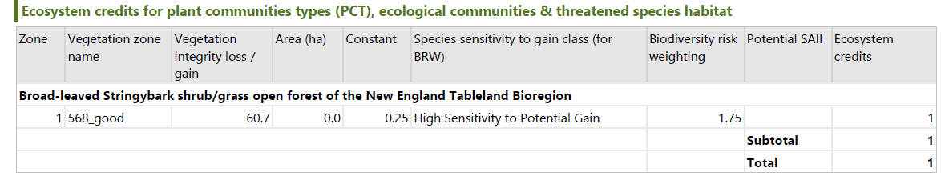

21. | In accordance with the Biodiversity Development Assessment Report and Addendums prepared by Eco Logical Australia for the development, the class and number of Species credits as detailed in the tables below, must be retired to offset the residual biodiversity impacts of the development.  The requirement to retire credits may be satisfied by payment to the Biodiversity Conservation Fund of an amount equivalent to the class and number of Species credits, as calculated by the BAM Credit Calculator (BAM-C).  Evidence of the retirement of credits or payment to the Biodiversity Conservation Fund in satisfaction of this condition, must be provided to the consent authority prior to the release of the Construction Certificate.

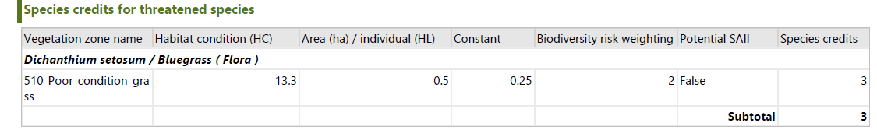
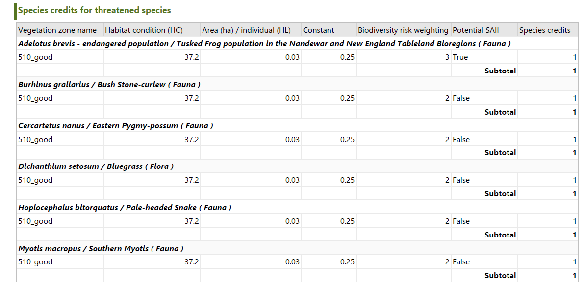
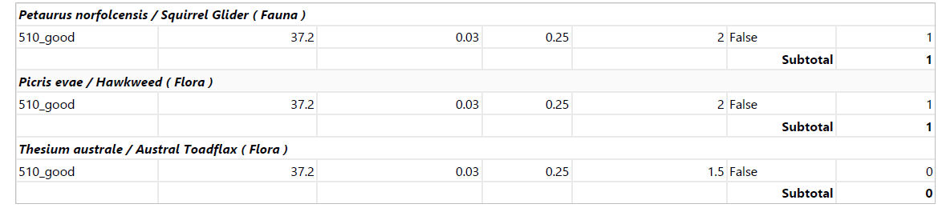

22. | Pursuant to Section 7.12 of the Environmental Planning and Assessment Act 1979, the monetary contribution set out in the following table is to be paid to Council prior to the issue of a Construction Certificate.  The contribution is current as at the date of this consent and is levied in accordance with the Armidale Regional Council Section 7.12 Contributions Plan 2018, adopted on 1 November 2018, which may be viewed during office hours at Council’s Customer Service Centres, 135 Rusden St, Armidale, or 158 Bradley Street, Guyra and on Council’s website www.armidaleregional.nsw.gov.au.  The contribution payable will be calculated in accordance with the contributions plan current at the time of payment, and will be adjusted at the time of payment in accordance with the Consumer Price Index (CPI) (All Groups Index for Sydney) published by the Australian Bureau of Statistic (ABS). Contribution amounts will be adjusted by Council each quarter.  Contribution Type Proposed Cost of Development * Levy Percentage Total Contribution Contribution Rate remains current until first date of next quarter  Section 7.12 Contribution $32,120,000 1.0% $321,200 1.1.2020  *Proposed cost of carrying out the development less any credits which may apply.
23. | Approval is to be obtained from Council as the roads authority pursuant to s138 of the Roads Act 1993 for all construction work required on Council road reserves.
DURING CONSTRUCTION

24. | Effective dust control measures are to be maintained during the construction phase of the development to maintain public safety/amenity and prevent nuisance dust emissions from associated with construction traffic.  ADVISING: Failure to take effective action may render the developer liable to prosecution under the NSW Protection of the Environment Operations Act.

25. | Approval is to be obtained from Council as the roads authority pursuant to s138 of the Roads Act 1993 for all construction work required on Council road reserves, specifically installation of property vehicular accesses (driveway cross-over).  The approval is to be obtained through a s138 application prior to any such works being undertaken within the road reserve, confirming that the works will meet Council’s Driveway Handbook and standard drawings, which can be found on Councils website (www.armidaleregional.nsw.gov.au).  Advising: the activity is to be protected by public liability insurance with a minimum cover of $20 million.

26. | No storage of building materials, soil or equipment is to occur on Council's property or roads without the written consent of Council’s Civic and Recreational Services Manager or nominee. No unfenced, potentially dangerous activity or material to be located in close proximity to the street boundary or pedestrian walkway adjoining the site. No unsupervised transit of plant, equipment or vehicles across public areas or other obstruction of those areas is permitted.

27. | Any fill which is placed on the site shall be free of any contaminants and placed in accordance with the requirements of AS 3798 (current edition) Guidelines on Earthworks for Commercial and Residential Developments. A suitably qualified consultant shall:  - identify the source of the fill and certify that it is free from contamination; and  - classify the area within any building envelope on any such filled lot in accordance with the requirements of "Residential Slabs and Footings" AS 2870.1 (current edition).
28. | The hours of all construction work for the development are to be restricted to between 7.00am and 6.00pm on Monday to Friday and 8.00am to 1pm on Saturday, to maintain the amenity of the locality. Only non audible works are permitted to be undertaken outside these hours.  Any proposed building work to be undertaken outside these hours or on Public Holidays must be the subject of prior written agreement from Council - consideration may be given to special circumstances and non-audible work if applicable.  ADVISING: Breaches of this condition may result in the issuing of a Penalty Infringement Notice or prosecution.
29. | Toilet facilities are to be provided at, or in the vicinity of the work site, at the rate of one toilet for every 20 persons or part of 20 persons employed at the site. Each toilet provided must be connected to an accredited sewage management facility approved by the council or some other sewage management facility approved by the council.
30. | The development must be carried out in accordance with Managing Urban Stormwater: Soils & Construction (4th edition, Landcom, 2004), commonly referred to as the “Blue Book” and as in force at the date of this consent; to maintain public and environmental safety and amenity, and prevent erosion and sedimentation.  ADVISING: Failure to take effective action may render the developer liable to prosecution under the NSW Protection of the Environment Operations Act.
31. | A further glare assessment is to be undertaken once the panel layout is confirmed, to ensure that the location, siting and angle of the panels on site, does not result in any unacceptable glare for sensitive receptors/adjoining properties.
BEFORE COMMENCEMENT OF OPERATION
32. | Prior to the commencement of the operation of the solar farm, the planting associated with the landscape screen (as approved under Condition 15 of this consent) must be planted in accordance with the approved plan, unless otherwise varied and agreed to by Council where drought conditions may inhibit this from occurring.
33. | Following construction, the applicant must:  - Restore the ground cover of the site as soon as practicable, using suitable species; and  - Maintain ground cover.
34. | All security fencing is to incorporate scratch barriers to ensure that fencing containing barbed wire is clamber proof to prevent the potential for entanglement of fauna.

OPERATIONAL CONDITIONS
35. | The developer must ensure:  - The internal roads are constructed as all-weather roads;  - There is sufficient parking on site for all vehicles, and no parking occurs on the public road network in the vicinity of the site;  - All vehicles are loaded and unloaded on site, and enter and leave the site in a forward direction; and  - Vehicles leaving the site are in a clean condition and do not result in dirt being tracked onto the public road network.
36. | The solar farm is to be decommissioned to the satisfaction of Council and the site returned to pre construction agricultural use, once the use has ceased and/or become inactive for more than 12 months.  All decommissioning is to be undertaken in accordance with the approved plan/s unless varied by Council.
37. | The ongoing operational phase of the solar farm development is to be undertaken at all times in accordance with all approved and adopted Plans.
38. | Any lighting used on site in connection with the development is to comply with AS 4282 – Control of the Obtrusive Effects of Outdoor Lighting.
39. | The developer must implement all reasonable and feasible measures to prevent and/or minimise any material harm to the environment that may result from the construction, operation, or decommissioning of the development, including weed control.
40. | On-going monitoring of the health and performance of the visual plant screen during the life operation of the solar farm. Plant stock must be replaced, whenever necessary, to ensure the screen continues to act as an effective visual barrier.
41. | The developer must:  - minimise the off-site visual impacts of the development, including the potential for any glare or reflection from the solar panels;  - ensure the visual appearance of all ancillary infrastructure (including paint colours) blends in as far as possible with the surrounding landscape; and  - not mount any advertising signs or logos on site, except where this is required for safety purposes.
42. | The applicant must:  - Store and handle all dangerous or hazardous materials on site in accordance with AS1940-2004: The storage and handling of flammable and combustible liquids, or its latest version; and  - Minimise any spills of hazardous materials or hydrocarbons, and clean up any spills as soon as possible after they occur.
43. | The development is to be provided at all times with a minimum 20,000 litre dedicated water supply for fire fighting purposes.

ADVISING

Note 1
In the event that Aboriginal artefacts are identified on the site during development through earthworks or construction, the Applicant shall contact the National Parks and Wildlife Service (NPWS – part of the Office of Environment and Heritage) and cease work in the relevant location pending investigation and assessment of its heritage value by NPWS and the relevant local Aboriginal groups.
A ‘Consent to Destroy’ Application under section 90 of the National Parks and Wildlife Act 1974 must be submitted and issued by the Director-General of National Parks and Wildlife for any Aboriginal archaeological sites that are to be damaged or destroyed as a result of any development. The Applicant shall consult with the relevant local Aboriginal groups and to the satisfaction of the NPWS prior to any ‘Consent to Destroy’ Application being submitted.
For further information see the NPWS Code of Practice for Archaeological Investigations in NSW:
http://www.environment.nsw.gov.au/licences/archinvestigations.htm

Note 2
In the event that any relics, being any deposit, artefact, object or material evidence that:
(a) relates to the settlement of the area that comprises New South Wales, not being Aboriginal settlement, and
(b) is of State or local heritage significance,
are identified on the site during development through earthworks or construction, the Applicant/developer shall notify the NSW Heritage Council as required under s.146 of the Heritage Act 1977, as well as the Armidale Regional Council, of the find and await further advice before proceeding with the development.

